**Spring 2024: CS5720 Neural Networks & Deep Learning - ICP- 5**

**Sai Preetham Nagaswaram (700743350)**

GitHub Link: <https://github.com/Saipreethamnagaswaram/Neural-Network-Deep-Learning/tree/190eef2916a5ac3981650474cb4da0ef2074bbe1/Assignment%205>

1. Implement Naïve Bayes method using scikit-learn library

Use dataset available with name **glass**

Use **train_test_split** to create training and testing part

Evaluate the model on **test part** using score and

classification_report(y_true, y_pred)

**Solution & Output :**

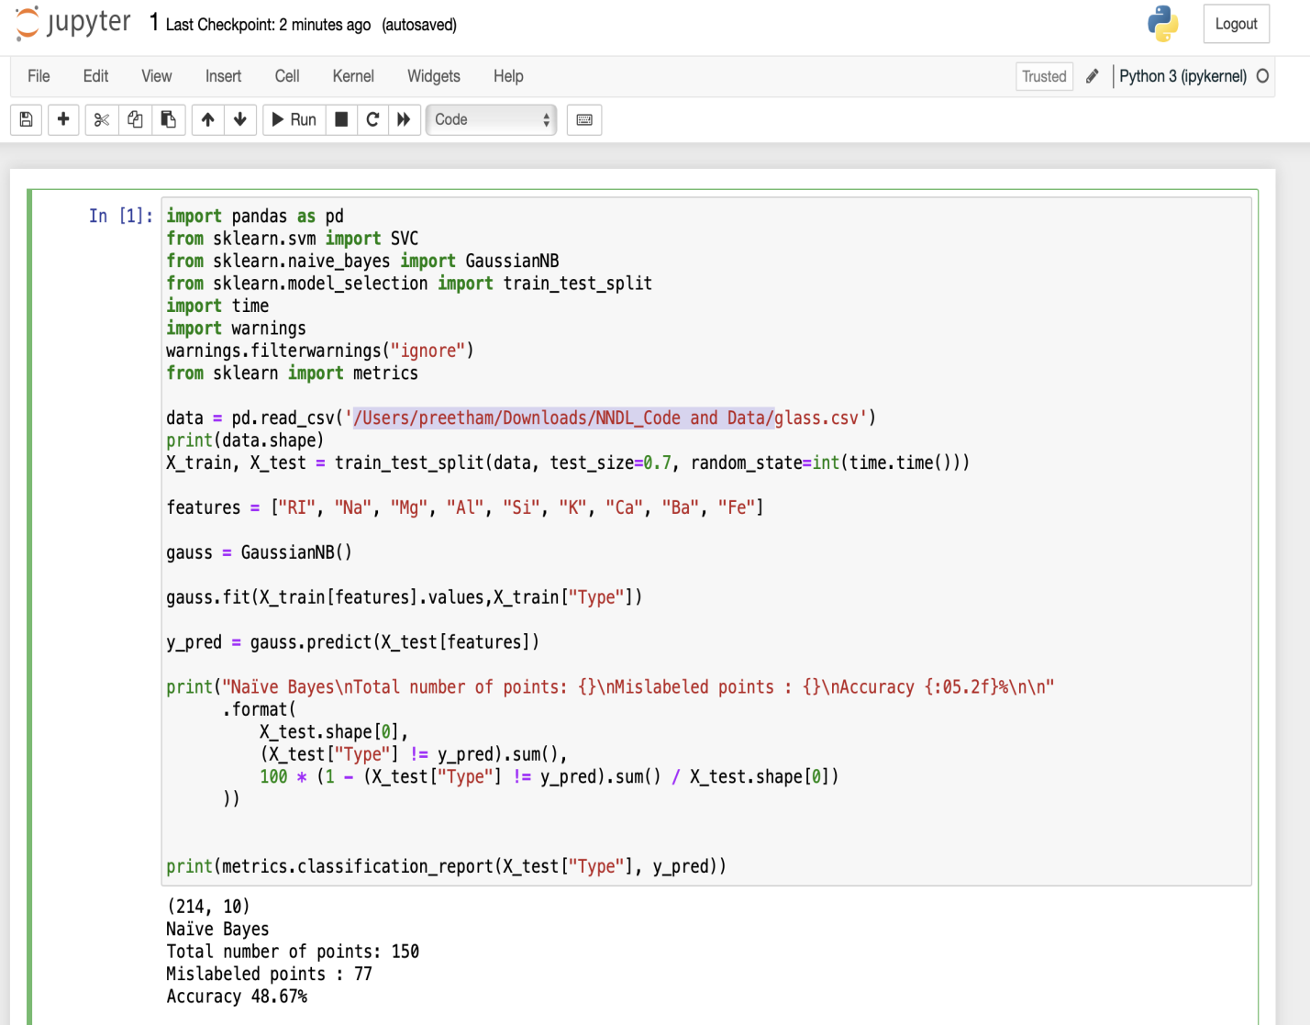

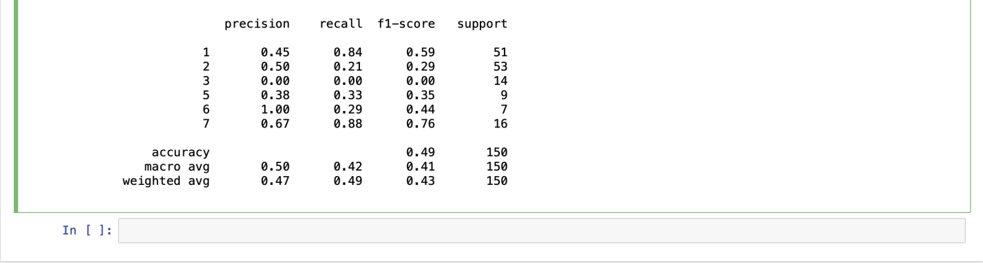

2. Implement linear SVM method using scikit library

Use the same dataset above

Use **train_test_split** to create training and testing part

Evaluate the model on **test part** using score and

classification_report(y_true, y_pred)

Which algorithm you got better accuracy? Can you justify why?

**Solution & Output:**

